MOLECULAR DOCKING AND DYNAMIC APPROACH IN SILICO, DRUG REPURPOSING FOR LUNG CANCER BY TARGETING AT PI3Kα

**Tharannum, Sumit Birangal, and R.S. Jeyaprakash**

Department of pharmaceutical chemistry, Manipal College of Pharmaceutical Sciences, Manipal Academy of Higher Education, Manipal, Karnataka, India

ABSTRACT

Cancer has emerged as a prominent contributor to mortality rates across the globe. Small cell Lung cancer (SCLC) and **non-small cell lung cancer** (NSCLC) **are two types of** lung cancer. NSCLC is becoming more prevalent worldwide. In this type of cancer, mutations in the PI3Kα pathway make it a significant target for cell proliferation. Targeting PI3Kα is considered a promising strategy in cancer treatment. Although PI3Kα inhibitors are investigated in many cancers, they can cause toxicity. NSCLCs are resistant to current treatments. Repurposed drugs can be safer, and cost-effective, as they are already available in the market with regulatory approval. Hence**, we use in silico structure-based virtual screening to identify US-FDA-approved drugs for repurposing.** PI3Kα was selected with a co-crystal ligand (PDB:4L23), and 2509 US-FDA legitimate drugs were imported from the Drug Bank for Structure-Based Virtual Screening to assess their activity on the target. Protein and ligands were prepared with Protein Preparation Wizard and LigPrep. Potential lead compounds from the database were extracted through molecular docking and Prime-MM/GBSA. The 20 molecules were shortlisted according to dock score, and the molecule was subjected to MM/GBSA $∆$ G binding score. The three compounds with the most favorable docking and MM/GBSA scores were selected for molecular dynamic. **MD simulations were used to evaluate the stability of the lead molecules,** with DBO3147 exhibiting the optimal results in terms of ligand-protein interactions, RMSD, and RMSF parameters. Computational drug discovery tools were used in this research to identify potential anticancer agents for NSCLC by repurposing US-FDA-approved drugs.

KEYWORDS: Lung cancer; non-small cell lung cancer; Molecular dynamic; Molecular Docking; PI3Kα; MM/GBSA;

**INTRODUCTION**

Cancer is a prevalent disease, is caused by uncontrollable cell development, aberrant cells that proliferate and spread out of control, is curable if diagnosed early. Breast, lung, colorectum, and prostate cancer are the most prevalent types. Here cancer cell grows in the body's normal cells. Cells multiply when the body requires them, and apoptosis will occur. Cancer develops when cells divide too quickly and cell growth is uncontrolled 1.

A malignant tumor can be cancerous and occur in any part of the body2. The most common malignancy to cause death is lung cancer 3. Most cancer fatalities are caused by metastasis, although this process is still one of the most mysterious features of the illness. The individual or small groups of cancer cells are separated from the tumor cell. The cell should have the ability to move to initiate the metastatic process. This feature allows moving through the extracellular matrix of the surrounding tissue in the direction of the blood and lymphatic vessels, which act as thoroughfares for the movement of cells to distant secondary sites 4. Lung cancer is a significant root of death globally (18.4% of all cancer fatalities). It can be treated by various interventions. It imposes a massive impact on society and negatively impacts the economy. The risk factor includes smoking, radon, asbestos extended use, continuous exposure to pollutants in the air, particularly Polycyclic Aromatic Hydrocarbons release, and predisposition5. Cancer is a complex disease with over 200 types that originate in different body parts and have diverse causes. Cancer can be classified based on tissue effect, i.e., carcinoma, sarcoma, leukaemia, adenoma, etc. Lung cancer comes under carcinoma 1. The three primary forms of NSCLC identified by the WHO are adenocarcinoma and squamous cell carcinoma. Many variations and combinations of clinical subtypes exist 6. Squamous cell carcinoma in non-small cell lung cancer (NSCLC) is one type of cancer that is thought to originate from abnormalities in the PI3K/Akt cascade, which is essential for the development and division of cells 7. This cascade has been strongly linked to cancer and tumor advancement. Elevation of this pathway activation causes several hallmarks of cancer, including accelerated growth signal autonomy, suppression of necrosis, ability to form new blood vessels, enhanced tissue invasion and metastasis, and insensitivity to antigrowth signals and other effects. This pathway is a desirable target for cutting-edge cancer treatments 8. Hence, novel molecules are needed to suppress the disease NSCLC because mutations in the biological target can develop medication resistance 7. The growth factor receptors in most types of cancer share common signaling cascades, PI3K, EGFR, STAT, MAPK, and others 7. PI3K/Akt/mTOR signalling cascades significantly control cellular development and metabolism. The PI3K signalling pathway demonstrated that cancer progression heavily depends on the complicated pathway's overexpression 8. Many cancers have the phosphoinositide-3-kinase pathway involved. The PI3K is essential for regulating the cell's growth and replication by receiving signals from external receptors such as RTKs and GPCRs. These signals are integrated by PI3K to ensure proper cellular function. The PI3K-alpha (PI3Kα) protein complex consists of the catalytic subunit p110a and the regulatory subunit p85a. It is inducted to the plasma membrane where it phosphorylates phosphatidylinositol 4,5-bisphosphate (PIP2) to generate phosphatidylinositol 3,4,5-trisphosphate (PIP3). This, in turn, recruits AKT kinases to the membrane, which activates PDK1 and mTORC2 phosphorylation. Activated AKT kinases can phosphorylate TSC2, negatively regulating the activity of the mTOR kinase. Additionally, mTORC1 phosphorylates and activates S6K 9. PI3K has four classes such as I, II, III, and IV. 7 There are two subclasses of PI3Ks, with class I further subdivided into subclasses IA and IB. While only class IA has been connected to cancer, this pathway is frequently disrupted due to genetic alterations in the enzymes and effectors within the cascade. Alteration in genes makes commonly affected pathways in many cancer 10. Due to its crucial function in the PI3K pathway, PI3Kα has been identified as a prospective target for therapeutic development. The kinase enzyme is altered by phosphorylation, which leads to the functional imbalance of PI3Ks and changes the enzyme's activity 7.

Human cancer typically exhibits dysregulation of the PI3K pathway, and one of the most often changed kinases in human cancer is PI3Kα 11. As per the studies, this pathway is an appealing target for discovery of novel molecule for cancer therapy 8.

NSCLC is not identified until the disease has progressed to an advanced stage. The most frequent symptom is cough, experienced by 50% to 75% of patients. Other symptoms include hemoptysis, chest discomfort, and dyspnea. Laboratory abnormalities or paraneoplastic syndromes are other, less uncommon symptoms. 6

Non-small lung cancer can be treated on the bases of the cancer stage. In the initial phase (stage I or II), the disease should undergo complete surgical removal of the tumor when it is not contraindicated. Conventional or stereotactic radiation should be considered for patients not treated with surgical intervention 6. Implementing targeted therapy and ICI has significantly transformed the treatment of NSCLC patients. Immuno-therapy, combined with chemotherapy, has become the primary standard treatment mode. Although there are uncertainties regarding the appropriate sequence and combination of these novel agents, the field is progressing rapidly, with clinical trial outcomes and other research findings being disseminated faster than ever in the history of NSCLC 6. Most anticancer medications have limited therapeutic effectiveness since they lack selectivity and have serious adverse effects 12.

The exploration of repurposing drugs for cancer therapy has become a growing interest among researchers 13. In addition to the challenges of developing new molecular entities, repurposing drugs has more benefits. Ensuring the affordability of effective cancer treatments is crucial in reducing cancer mortality rates, especially for patients living in LICs and MICs. Repurposing drugs that have been proven safe and effective could be a potential solution to the issue of limited access to the latest drugs for many cancer patients. It could also help to alleviate the financial burden on those who can afford these treatments. The challenges a patient faces about the expenses associated with treatment and side effects related to the drug, like nausea, diarrhea, or hair loss, can impact the outcomes of cancer patients and, therefore, should be addressed accordingly. The exorbitant pricing of cancer drugs globally burdens individuals and their families already dealing with significant physical, financial, and emotional challenges related to cancer and the repurposing of the drug. The pharmaceutical industry assumes the high-risk economic aspect of drug discovery through drug repurposing, leading oncological products to be subject to marketing laws.

Consequently, most newer cancer drugs are not only too expensive for most patients globally but may also lack significant clinical benefits based on current measurement scales. One of the significant advantages of drug repurposing is that potential candidates are often inexpensive, especially those that are generic and produced by multiple manufacturers 13. Clinical trials can be expedited once a suitable viable target for a repurposed drug has been found and confirmed for cancer treatment. The literature-derived ADME data supports that the candidate drug is achievable in vitro antitumor activity. This is because the knowledge of the drug's safety profile, including rare adverse events, can accelerate the clinical trial process 13. The targeted therapy on pi3k alpha was studied using computer-aided drug design. A new class of molecule with high PI3K potency and distinctive PI3K isoform selectivity was developed using SBVS and computational analysis 11. To innovate anticancer drugs, maximum effectiveness, and minimal toxicity are essential in novel therapeutic anticancer drugs 12.

This study aims to repurpose the FDA-approved drugs on pi3k alpha by using structural-based virtual screening and screening of 2509 drugs with the help of molecular-docking, MMGBSA free binding energy analysis, and MD simulations on the crystal structure of a protein. We are finding a selective inhibition of PIK3 alpha in treating NSCLC squamous carcinoma.

# Material and method

In research, we took specific biological targets pi3k alpha and FDA-approved 2509 drugs for repurposing on pi3k alpha. Protein 4L23 was taken from the protein database, studied structural base virtual screening, and screened 2509 drugs for further molecular docking, MMGBSA free binding energy analysis, and MD (molecular dynamics) simulations for optimizing the FDA-approved drugs and PI3Kα is selectively inhibited in the therapy of NSCLC squamous carcinoma using FDA-approved medicines

On an HP desktop computer running Ubuntu, computational simulations were performed using the Maestro user interface from the Schrödinger suite. The computer was equipped with a 4GB NVidia graphics card and an Intel® CORE® i3-5160 processor.

2.1 Protein preparation

The X-ray diffraction data from PDB was used to obtain structural insight of the PI3K-α 4L23 protein molecule, and its 3D structure was downloaded in PDB format14. The crystalline arrangement of the human PI3Kα- protein with PI103 complex was analyzed to understand the chemical interactions involved. The 15 study showed that changing the phenol part of PI103's R1 position increased binding affinity. With Lys802, which is found at the base of the ATP catalytic site, it created an entirely novel hydrogen bond. This crystalline arrangement provides valuable insights into the specific and robust interactions involved and highlights the significance of Lys802 in designing novel PI3Kα inhibitors 15. The downloaded Homo sapiens protein, classified as a signaling protein, has been observed with a resolution of 2.50 Å and no mutation. An R-Value of 0.218 falls within the agreeable range for the protein. The protein preparation wizard tool, part of the maestro workspace, was used to construct the receptor molecules. 14. To prepare the protein for further analysis, the initial step

1. Involved importing the specific protein
2. Prime can be used to complete any missing gaps in the loops or chains.
3. The next step was chain refinement, side chains were removed..
4. Subsequently, the target was optimized using a PROPKA pH of 7.4
5. Beyond 5 Å, the water molecules were eliminated.

After the protein underwent energy minimization using the OPLS3e force field, resulting in a lower energy state protein suitable for further analysis 16.

Table 1: Protein information

|  |  |  |  |  |
| --- | --- | --- | --- | --- |
| Protein | Classification | Organism | Resolution | Bound to |
| 4L23 | Signalling protein/ transferase | [Homo sapiens](https://www.rcsb.org/search?q=rcsb_entity_source_organism.taxonomy_lineage.name:Homo%20sapiens) | 2.50 Å | niSH2 of p85alpha and  PI-103 |

2.2 Ligand preparation

The ligand molecules were obtained from the Drug Bank database, and subsequently, the Drug Bank molecules downloaded were FDA-approved drugs 14. Repurposing FDA-approved drugs involved downloading approximately 2509 compounds and importing them into Maestro. After importing the total number of compounds will be 2466. The LigPrep application was utilized to optimize energy and generate precise 3D structures of the drug molecules. A notable feature of LigPrep is its ability to eliminate ligand errors and produce optimized structures that can be used for further processing, such as Glide and virtual screening, as well as MD simulations 7. The LigPrep module in the maestro workspace was employed to prepare the ligand molecules. Ligprep was prepared for 2357 compounds and performed at the same pH as protein preparation. Like the protein energy minimization, we are subjecting to the ligand molecule The original configuration of the chiral centers in the ligand molecules was maintained to prevent the formation of stereoisomers 14.

2.3 Receptor grid generation

Following the energy minimization of the protein (PDB: 4L23), the Glide module created a receptor grid that provided the active location for ligand-receptor docking. The ligand was selected from the prepared protein to generate the receptor grid and excluded from the grid calculation to avoid interference during ligand-protein docking. Grid was generated using standard settings, including site constraints, van der Waals radius scaling, and volume exclusion by cutting off partial charge. An essential aspect of the drug repurposing strategy involves predicting the binding site and analyzing pocket draggability 7,14,16.

2.4 Molecular/Ligand docking and validation of docking

Molecular docking is a valuable tool for investigate behavior of molecule in the binding site of target receptor and uncovering essential biochemical processes. In this study, the crystalline form (PDB Id:4L23) was employed to evaluate the robustness of the proposed protocol. The Schrödinger suite's Maestro interface was utilized for molecular docking studies using the XP technique in Glide, which provided suitable docked pose and dock and Glide scores for further analysis of the active site for ligand binding. This approach effectively identifies drug like molecule and facilitates compound optimization in SBVS through in silico docking, where the receptor is kept rigid. The action of molecules in the target protein's active site is analyzed to uncover critical biological processes.

Ligprep was prepared for 2357 compound, followed by SP (standard precision) docking for the best 2183 molecules. Glide XP (enhanced precision docking) was applied to the top 295 molecules. Based on binding score and chemical interactions with the target receptor/protein, the top 20 ranked molecules were chosen for additional investigation 7,16–19.

2.5 MMGBSA

The XP docking method yielded favorable scores and poses for the ligands. The docked complex was subjected to Mechanics/Generalized Born Surface Area (MM-GBSA) using Prime to determine whether ligand binding to the protein active site might have any biological effects 18,20.

To determine the affinity between the protein and ligands, the MMGBSA calculation method was employed using the Prime module. This method calculated each ligand molecule's relative binding free energy (DGbind). The highest ranked 20 molecule from the XP docking study were subjected to MMGBSA analysis to calculate their binding affinity and energies in the ligand-receptor complex. It's critical to remember that the precision of the MMGBSA method is dependent on sufficient sampling and the quality of the molecular mechanics (MM) potential used. The binding free energy was also calculated using the MMGBSA study to validate the docking score. A ligand interaction diagram was also visualized to gain insight into the ligand-receptor contacts.7,14,21,22

2.6 Molecular dynamics simulation (MD)

The utilization of molecular simulation is prevalent for comprehending the atomic-level behaviour of molecules, and the simulations were executed through the Desmond software 17. This technique is used widely to better understand protein and protein-ligand systems' functionality and dynamics. Near-physiological-motion MD simulations were employed to dynamically simulate the complex design of targeted molecules and a well-known drug obtained from ligand docking. Since molecular docking doesn't accurately represent the bioactivity in which the protein and ligand are exhibited, MD simulation addresses this issue. The resulting study of docking ligand-protein complex was utilized for MD simulation studies, and for simulation Desmond integrated with Maestro was employed. The MD simulation process comprises three stages: system builder, minimization, and dynamics, was utilized for the simulation. Before the dynamics were performed, an SPC (single point charge) solvent model was employed to submerge the entire system. The system was built with an orthorhombic box boundary condition. To neutralize the system, 0.15 M NaCl was added to the buffer, and Desmond's Minimization tool was used to minimise the system. The molecular dynamics (MD) simulation was run for 100 nanoseconds (ns) using a graphics processing unit (GPU). The simulation generated approximately thousand frames with a recording interval of hundred frames s-1. The NPT ensemble class was used to control the temperature and pressure of the system, keeping them constant at 300 K and 1.01325 bar throughout the simulation. Finally utilising the SID (Simulation Interaction Diagram) tool integrated into Desmond, reports were produced.7,14,16,18,22–25

# Result and discussion

A structure-based approach in computer-aided lead identification has recently gained popularity in computational chemistry. Advancements in artificial intelligence and machine learning have made hit-to-lead optimization more efficient. Additionally, virtual screening techniques have opened up new possibilities for drug discovery. Nsc lung cancer is a condition that is frequently studied because of its multiple signalling cascades, mutagenesis, growth factors, and potential for therapeutic development. The first step is identifying an appropriate target for the research process. After thoroughly examining cancer signalling cascade,PI3Kα has been chosen as a potential target for inhibiting cell proliferation mutation factors. PI3Ks are crucial in cell proliferation, motility, apoptosis, and division. PI3Kα is a frequently implicated isoform in a different cancer, and it continues to be extensively researched in oncology. Several clinical inhibitors of PI3Kα are currently being evaluated. A dysregulation or mutation in the PI3K signalling can result in cancer formation and progression such as NSCLC. As a result, PI3K has become an attractive target for medical study. This protein was chosen specifically for its involvement in the growth of resistance and mutation factors related to NSC lung cancer. This study used SBVS. At a pH of 7.4 ± 0, the PI3Kα protein was made, and the ligands were also prepared under the same conditions using the FDA Approved drug database. To create the receptor grid, we used the method outlined above 7,16,26–28.

# 

**(A)DB01698**

**(B)DB03147 (C)DB01204**

# 

**(D) Cocrystal-Ligand**

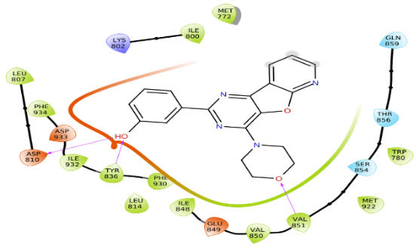

Figure 1: Two-dimensional interaction diagrams with protein were created for the top three compounds (A) DB01698, (B) DB03147, and (C) DB01204, along with the co-crystal ligand (D).

Table 3: The results from the top 20 compounds obtained from molecular docking showcasing their respective structures, docking scores, and MMGBSA ∆G values.

|  |  |  |  |  |  |
| --- | --- | --- | --- | --- | --- |
| Sr.no | Databank id of the compounds | Structure | Name of the compound | Dock score | MMGBSA $∆$ Gbind |
| 1 | DB08995 |  | Diosmin | -14.547 | -49.64 |
| 2 | DB01698 |  | Rutin | -13.575 | -75.98 |
| 3 | DB03147 |  | Flavin adenine dinucleotide | -13.507 | -54.65 |
| 4 | DB11263 |  | Polydatin | -12.887 | -49.90 |
| 5 | DB06193 |  | Pixantrone | - 11.914 | -52.34 |
| 6 | DB14086 |  | Cianidanol | -11.849 | -41.48 |
| 7 | DB12332 |  | Rucaparib | -11.445 | -31.57 |
| 8 | DB09134 |  | Ioversol | -11.309 | -45.15 |
| 9 | DB00176 |  | Fluvoxamine | -11.186 | -31.91 |
| 10 | DB04703 |  | Hesperidin | -10.964 | -32.94 |
| 11 | DB01362 |  | Iohexol | -10.655 | -30.31 |
| 12 | DB08947 |  | Iopamidol | -10.513 | -27.09 |
| 13 | DB00642 |  | Pemetrexed | -10.461 | -25.83 |
| 14 | DB01204 |  | Mitoxantrone | -10.400 | -74.77 |
| 15 | DB00140 |  | Riboflavin | -10.210 | -63.72 |
| 16 | DB00890 |  | Dienestrol | -10.144 | -31.81 |
| 17 | DB00929 |  | Misoprostol | -10.115 | -43.52 |
| 18 | DB03247 |  | Flavin mononucleotide | -10.092 | -37.24 |
| 19 | DB13956 |  | Estradiol valerate | -10.077 | -38.56 |
| 20 | DB09026 |  | Aliskiren | -9.99 9 | -44.67 |
| 21 | Co-crystal ligand |  | **3-(4-Morpholin-4-ylpyrido[3',2':4,5]Furo[3,2-D]Pyrimidin-2-yl)Phenol** | -9.87 | -50.29 |

Table 4: Top 3 selected compound

|  |  |  |  |  |
| --- | --- | --- | --- | --- |
| Sr.no | Databank id of the compounds | Name of the compound | Docking score | MMGBSA DGbind |
| 1 | DB01698 | Rutin | -13.575 | -75.98 |
| 2 | DB03147 | Flavin adenine dinucleotide | -13.507 | -54.65 |
| 3 | DB01204 | Mitoxantrone | -10.400 | -74.77 |
| 4 | Co-crystal ligand | **3-(4-Morpholin-4-ylpyrido[3',2':4,5]Furo[3,2-D]Pyrimidin-2-yl)Phenol** | -9.87 | -50.29 |

Table 5: Interaction of compounds with pi3kα (PDB: 4L23)

|  |  |  |
| --- | --- | --- |
| Sr.no | Databank id of the compounds | Interaction |
| 1 | DB01698 | H-BOND: GLN859, SER919, VAL851, ASP810 (2), ASP933 ,TYR836  Π-Π STACKING: TRP780 |
| 2 | DB03147 | H-BOND: ASP810, TYR836, LYS802, ALA775, SER774, ASP 933, ASN920, ASP 915  Π-Π STACKING: TYR836 |
| 3 | DB01204 | H-BOND: ASP 933(2), SER854, VAL851  Π-Π STACKING: TRP780, TYR836  SALT BRIDGE: ASP933 |
| 4 | Co-ligand | H-BOND: ASP810, TYR836, VAL851 |

TYR: Tyrosine, ASN- Asparagine, SER: Serine, GLN: Glutamine, TRP-Tryptophan, LYS**-** Lysine, ASP: Aspartic acid, acid, ALA: Alanine, VAL- Valine.

3.1 Protein preparation and receptor grid generation

We prepared the PI3Kα protein at pH 7.4 using the protein preparation functionality within the Maestro interface. This offers several tools that simplify the complex energy minimization process into a user-friendly workflow for researchers. Glide looks for potential binding regions within the active area of the target protein, employing a hierarchical set of screening criteria. Additionally, the target grid generation was conducted in the active site of the reference ligand to enable additional investigation employing the molecular docking approach based on Glide. The materials and methods section detailed this study's receptor grid generation workflow7,29.

3.2 SBVS by molecular docking

Screening a drug library with many compounds is costly and time-consuming, especially when considering the rates of false positives and negatives. Molecular docking analysis is a valuable tool for understanding how molecules bind within the pockets of proteins/receptors. In this study, Schrodinger software was utilized for conducting ligand docking analysis. The initial stages of energy minimization in both protein and ligand preparation are crucial for studying drug-receptor interactions. Thus, ligand-receptor docking has become a preferred computational technique for in-silico evaluation while identifying promising compounds in drug discovery. This offers the advantage of being speedy and efficient while demanding minimal resource allocation. In this study, ligand preparation of 2466 molecules from the US FDA-approved drug database was performed using LigPrep. Like the protein preparation, the ligand preparation was performed at a pH of 7.4. only 2357 molecules were subjected to ligPrep. After ligand preparation of 2357 molecules using LigPrep, 2183 molecules underwent structure-based virtual screening with SP (standard precision) docking. According to the ligand docking score, only the topmost 295 molecules with a score above -7 were selected for further XP docking analysis. From this analysis, the best 20 molecules Based on the docking score, with a score above -9.999, were selected for further analysis and identified for more in-depth analysis of their binding interactions with the receptor using the same grid created with PDB 4L23. Conducting ligand docking led to more significant energy optimization and ligand-protein affinity comprehension. Because SP docking might result in false-positive findings, XP docking was selected for its more accurate outcomes.

The Glide XP (extra-precision) docking method generated the ligand-receptor interaction and docking score. The XP dock score range for the 20 molecules chosen was between -14.547 and -9.999, indicating a significantly better interaction than the docking score of the co-crystal ligand, which is 9.78. The 20 best compounds' binding energies were calculated using the Prime module of MMGBSA. All 20 compounds remained firm in the docked position, suggesting that these FDA-approved medications might function as PI3Kα inhibitors 7,14,16,18.

Table 3 presents the structures of the top 20 molecules selected, including compound ID DB08995, DB01698, DB03147, DB11263, DB06193, DB14086, DB12332, DB09134, DB00176, DB04703, DB01362, DB08947, DB00642, DB01204, DB00140, DB00890, DB00929, DB03247, DB13956 and DB09026 in addition to the docking score, as well as their corresponding ligand binding energy, the MM/GBSA DG score was calculated using the MMGBSA Prime module.

The correlation between the experimentally measured biological activity and the calculated overall binding free energy values anticipated from the MM/GBSA calculation has been emphasized in recent literature studies. Three molecules were chosen based on their docking score and MMGBSA binding affinity values, which ranged between -75.98 and -54.65 kilocalories per mole, in comparison to the standard drug, with a value of 50.29 kilocalories per mole. The ligand DB01698 (Rutin) has a docking score of -13.575 kilocalories per mole. MMGBSA binding affinity values are -75.98, DB03147 (Flavin adenine dinucleotide) has a docking score of –13.506 and MMGBSA binding affinity value -54.65 and DB01204(Mitoxantrone) has a docking score of –10.400 and MMGBSA binding affinity values -74.77 ligand DB00140 has score -10.210 and MMGBSA binding affinity values – 63.72 kcal/mol but this not included in the final selection due to its lower molecular docking score compared to the other molecules.

Table 4 presents the Top 3 molecules selected on the base of docking and MMGBSA ∆G score. The results suggest that these FDA-approved drugs have the potential to act as inhibitors of PI3Kα.

The top three molecules, including compound ID DB01698 (Rutin), DB03147 (Flavin adenine dinucleotide), and DB01204 (Mitoxantrone), exhibited noteworthy interactions in comparison to all other molecules in the FDA-approved database and significant interactions in the specific active-site of PI3Kα (PDB ID: 4L23).

It can be claimed that ASP810, an amino acid residue, performed the largest role in the H bonding interaction based on the grid-based XP docking study of the top 20 compounds. This was followed by VAL851, after which TYR836 and LYS802 also contributed to the interaction.

The crystal structures obtained from the study give a molecular foundation for the specific and robust interactions observed, highlighting the significance of Lys802 in developing new inhibitors for PI3Kα 15.

The drug rutin showed H bond interaction with GLN859, SER919, VAL851, ASP810 (2), ASP933, TYR836, and Π-Π STACKING with TRP780. Flavin adenine dinucleotide exhibited non-covalent hydrogen bond interaction with ASP810, TYR836, LYS802, ALA775, SER774, ASP 933, ASN920, ASP 915 and Π-Π STACKING with TYR836. Mitoxantrone drug present non-covalent hydrogen bond interaction ASP 933(2), SER854, VAL851, and Π-Π STACKING with TRP780, TYR836, and SALT BRIDGE interaction with ASP933. The standard ligand displayed H bond interaction with ASP810, TYR836, and VAL851. Notably, all molecules in this study interacted with at least one of the residues ASP810, TYR836, or VAL851, similar to the standard ligand.

(A) 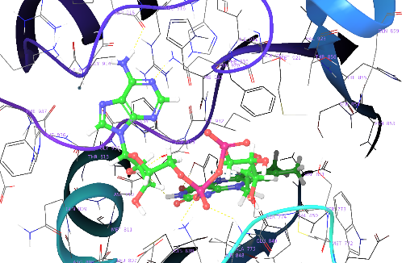 (B) 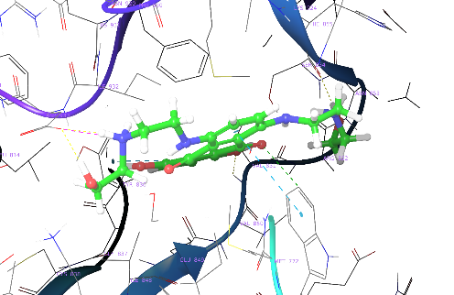

(C) 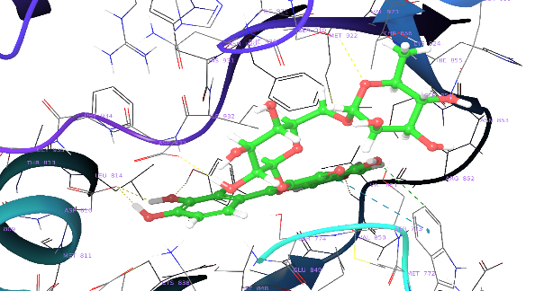 (D) 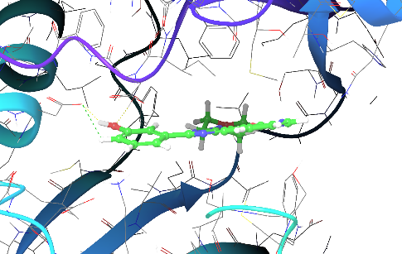

Figure 2: 3D ligand interactions and scores of the top three selected drugs compared with the co-crystal ligand. Ligand interaction of (A)DB01698, (B)DB03147, (C)DB01204, and cocrystal

3 MOLECULAR DYNAMIC

Computation simulation analysis was conducted to confirm the robustness of the interaction between the protein and its associated ligand and the as well as to validate the proposed binding configuration. This method is preferred as it can accurately simulate biological systems. The computational model provided a detailed and dynamic molecular conformation of the complex with water molecules included. The data obtained from the simulation revealed changes in the protein's conformation and the ligand-receptor/protein interaction. The Desmond application in the Maestro interface was used for the simulation. During the simulation, the binding site of the ligands was observed for 100 ns to analyze their interaction with the protein. The MD simulation study aimed to investigate different aspects of the ligand-receptor conjugate, including resilience,anticipation of the binding configuration and and type of of intermolecular connectivity with the binding site of the selected protein. The three top-performing molecules and the co-crystal ligand were selected based on their docking score, free binding energy, and non-bonding interactions with amino acids within the drug-binding pocket of thePI3Kα protein. To study their behavior in a dynamic context, MD simulations were conducted. Additional analyses such as RMSD analysis, protein-ligand contacts, and RMSF analysis were also performed. Highest docking score of three molecules was further MD simulation (A) DB01698 (Rutin), (B)DB03147(Flavin adenine dinucleotide), and (C)DB01204(Mitoxantrone) with the co-crystallized ligand was proceeded with ligand-dock score, free binding energy and complex formation with PI3Kα. The stability of the docking positions was assessed using the RMSD values. and to gather insights into the structural deviation and protein stability. The observed RMSD values for these medications were in the range of (1-3). Consequently, based on the outcomes of the MD simulation, Complex (B) DB03147 is more stable than Complex (A) DB01698 and (C) DB01204.

The root-mean-square fluctuations (RMSF) analysis was utilized to investigate the protein's local changes and residue-wise fluctuations during the simulation. The RMSF study shed light on the flexibility of residues that are important for the functioning of proteins. By identifying the residues responsible for structural fluctuations in the complex, the RMSF analysis helped characterize the protein-ligand complex's stability. A lower degree of fluctuations indicated better stability of the complex The RMSF of information presented in the graph (B) DB03147 is more convening since the protein had less changes. Fig 4. (C) for the DB01347–PI3Ka complex shows fewer Fluctuations.

In order to comprehend the protein-ligand complex, the consistency of protein-ligand interactions was also analyzed during the simulation process. Four categories of protein-ligand interactions or contacts—hydrophobic, H-bonded, ionic, and water bridge—can be used to classify protein interactions during the 100-ns MD simulation. protein–ligand contacts are hydrogen bonding interactions with ASP810, TYR836, VAL851 which are essential for the inhibitory function. Fig 6. (B) protein-ligand interaction of compound DB03147 with respective amino acids of the protein displays a deeper hue, signifying intense binding compare to the compound.

The MD simulation revealed that ligand DB03147 had the highest stability and potency as aPI3Kα inhibitor among the three tested molecules. 7,16,18

(A)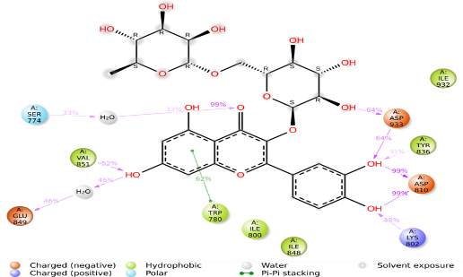 (B) 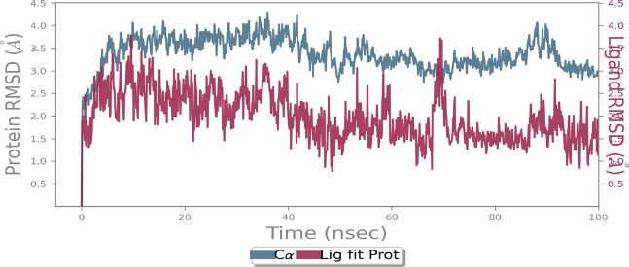

(C)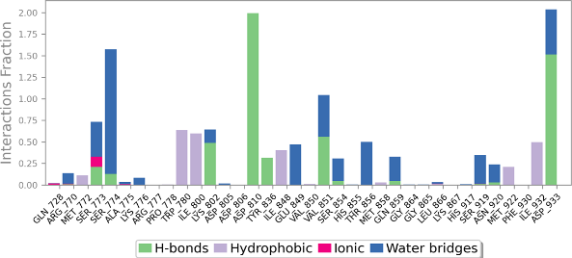 (D) 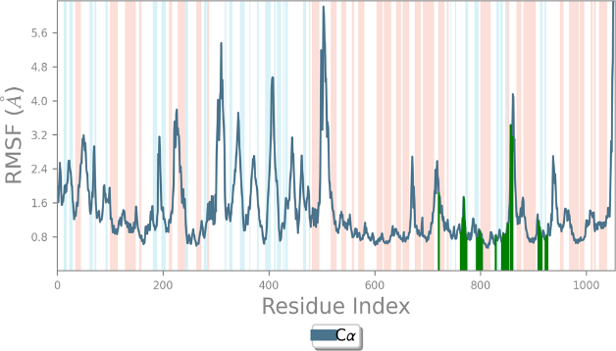

Figure 3: MD simulation for the DB01698–PI3Kα complex (PDB ID: 4L23), (A) interaction diagram ofPI3Kα– DB01698 after MD simulation, (B) the RMSD plot of thePI3Kα– DB01698 complex, (C) histogram of thePI3Kα– DB01698 complex, (D) RMSF of thePI3Kα– DB01698 complex

(A)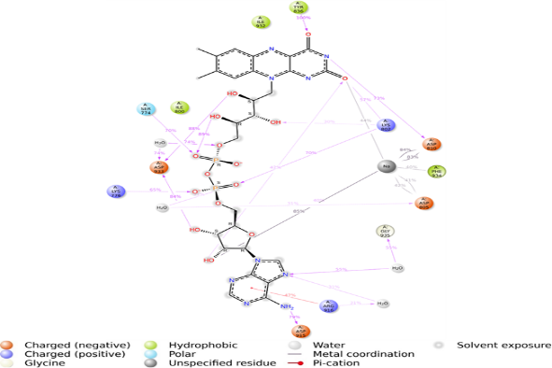 (B) 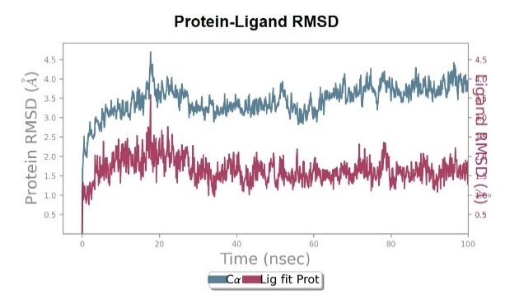

(C)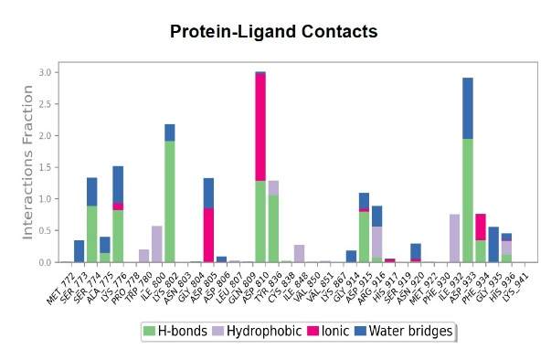 (D)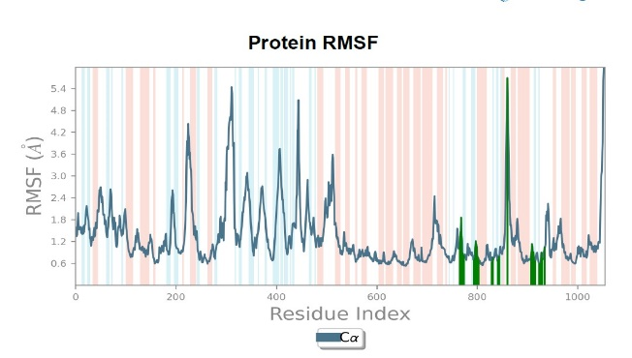

Figure 4: MD simulation for the DB03147–PI3Kα complex (PDB ID: 4L23), (A) interaction diagram of PI3Kα– DB03147 after MD simulation, (B) the RMSD plotof thePI3Kα– DB03147 complex, (C) histogram of thePI3Kα– DB03147 complex, (D) RMSF of thePI3Kα– DB03147 complex

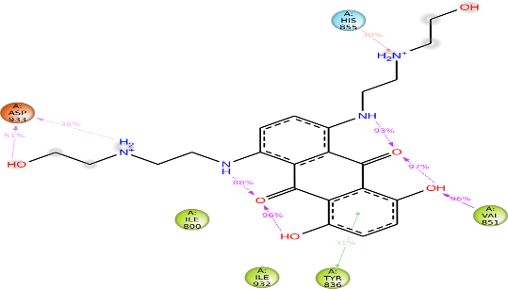 (B)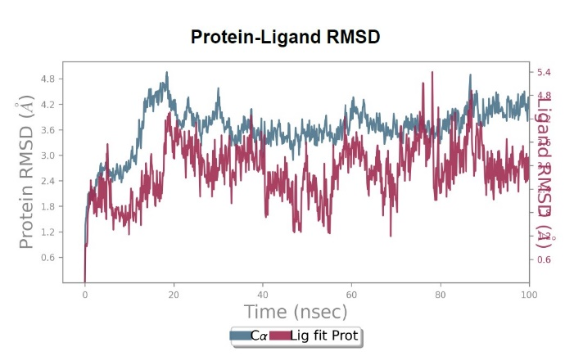

1. 

(C)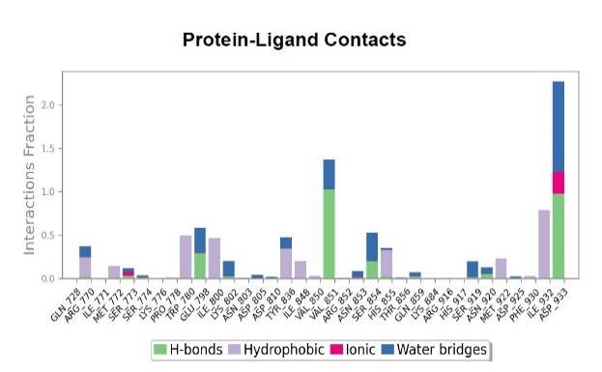(D) 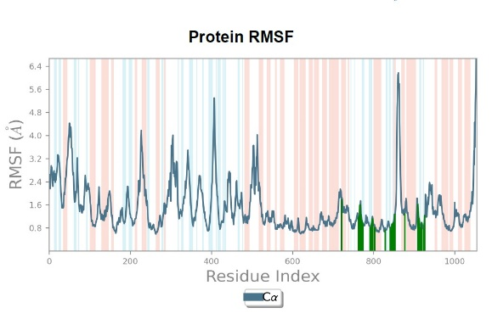

Figure 5: MD simulation for the DB01698–PI3Kα complex (PDB ID: 4L23), (A) interaction diagram of PI3Kα– DB01698 after MD simulation, (B) the RMSD plot of the PI3Kα– DB01698 complex, (C) histogram of the PI3Kα– DB01698 complex, (D) RMSF of the PI3Kα– DB01698 complex.

(A) (B)



Figure 6: Timeline representation of Protein-ligand interaction after 100-ns molecular dynamics; (A) protein-ligand interaction of compound DB01698 with respective amino acids of the protein, (B) protein-ligand interaction of compound DB03147 with respective amino acids of the protein, (C) protein-ligand interaction of DB01204 with respective amino acids of the protein. (Darker color indicates intense binding).

# Conclusion

Focusing on the PI3K pathway is a viable strategy for creating novel medications to treat non-small cellular lung tumors since it involves a significant role in many different forms of cancer. By inhibiting PI3Kα, slowing down or preventing cancer cell growth and promoting cell death may be possible. Small compounds are required for targeted treatment in order to suppress aberrant cell growth and proliferation. Consequently, this route is a desirable target for the development of new cancer therapies. This research is based on the virtual based repurposing of US-FDA approved drug on pi3k alpha. Drugs that have been repurposed save time and money because they are already on the market and have received regulatory approval. Also, the medication offers NSCLC patients a quick, inexpensive, and effective therapy of choice. Various computational approaches were employed to search through the Drug Bank for substances that might be PI3K alpha inhibitors. The protein used was obtained from the RCSB PDB (4L23) which includes a co-crystalized ligand. An overall of 2509 drugs were obtained from Drug Bank database and then ligPre was prepared for subsequently use. The compounds underwent structural-based virtual screening using SP and XP ligand-receptor docking methods. Glide XP docking was performed on all the ligands and the resulting receptor-ligand interactions. The topmost 20 compounds were chosen based on their ligand docking score and compared to the co-crystalized ligand. Among these compounds, those that showed better receptor-ligand interactions than the co-crystalized compound were further analysed using MMGBSA scoring. Finally, the 3 compounds that exhibited the most favorable docking scores and MMGBSA scores were selected for further investigation. DB01698, DBO3147, and DB01204 were among the three molecules that exhibited superior binding poses and interactions compared to the co-crystal ligand. Further molecular dynamics simulations were conducted to assess the durability of these lead molecules. DBO3147 showed the most favorable results in terms of ligand-protein interactions and in the RMSD and RMSF. This study highlights the potential of inhibitingPI3Kα in the treatment of NSCLC. It employs an in silico repurposing approach utilizing US FDA-approved drugs to identify the best molecules. These results indicate that more in vitro and in vivo tests of these lead compounds must be conducted in order to have a thorough understanding of this study, as they have the potential to serve as effective anticancer agents in the therapy of NSCLC.

# Reference

1. Nain S, Mathur G, Sharma PK. Cancer: An Overview. *Acad J Cancer Res*. 2015;8(1):1-09. doi:10.5829/idosi.ajcr.2015.8.1.9336

2. Patel A. Benign vs Malignant Tumors. *JAMA Oncol*. 2020;6(9):1488. doi:10.1001/jamaoncol.2020.2592

3. Chin G, Lim C. *Overview of Cancer in Malaysia*. Vol 32.; 2002.

4. Chaffer CL, Weinberg RA. A perspective on cancer cell metastasis. *Science (80- )*. 2011;331(6024):1559-1564. doi:10.1126/science.1203543

5. Lahiri A, Maji A, Potdar PD, et al. Lung cancer immunotherapy: progress, pitfalls, and promises. *Mol Cancer*. 2023;22(1):40. doi:10.1186/s12943-023-01740-y

6. Duma N, Santana-Davila R, Molina JR. Non–Small Cell Lung Cancer: Epidemiology, Screening, Diagnosis, and Treatment. *Mayo Clin Proc*. 2019;94(8):1623-1640. doi:10.1016/j.mayocp.2019.01.013

7. Debojyoti Halder, Subham Das, Aiswarya R, Jeyaprakash R. S. Molecular docking and dynamics based approach for the identification of kinase inhibitors targeting PI3Kα against non-small cell lung cancer: a computational study. *RSC Adv*. 2022;12(33):21452-21467. doi:10.1039/d2ra03451d

8. Tan AC. Targeting the PI3K/Akt/mTOR pathway in non-small cell lung cancer (NSCLC). *Thorac Cancer*. 2020;11(3):511-518. doi:10.1111/1759-7714.13328

9. Vasan N, Toska E, Scaltriti M. Overview of the relevance of PI3K pathway in HR-positive breast cancer. *Ann Oncol Off J Eur Soc Med Oncol*. 2019;30(10):x3-x11. doi:10.1093/annonc/mdz281

10. Yuan TL, Cantley LC. PI3K pathway alterations in cancer: Variations on a theme. *Oncogene*. 2008;27(41):5497-5510. doi:10.1038/onc.2008.245

11. Cheng H, Orr STM, Bailey S, et al. Structure-Based Drug Design and Synthesis of PI3Kα-Selective Inhibitor (PF-06843195). *J Med Chem*. 2021;64(1):644-661. doi:10.1021/acs.jmedchem.0c01652

12. Haider K, Ahmad K, Najmi AK, Das S, Joseph A, Shahar Yar M. Design, synthesis, biological evaluation, and in silico studies of 2-aminobenzothiazole derivatives as potent PI3Kα inhibitors. *Arch Pharm (Weinheim)*. 2022;355(10). doi:10.1002/ardp.202200146

13. Gonzalez-Fierro A, Dueñas-González A. Drug repurposing for cancer therapy, easier said than done. *Semin Cancer Biol*. 2021;68:123-131. doi:10.1016/j.semcancer.2019.12.012

14. Thirunavukkarasu MK, Suriya U, Rungrotmongkol T, Karuppasamy R. In Silico Screening of Available Drugs Targeting Non-Small Cell Lung Cancer Targets: A Drug Repurposing Approach. *Pharmaceutics*. 2022;14(1). doi:10.3390/pharmaceutics14010059

15. Zhao Y, Zhang X, Chen Y, et al. Crystal structures of PI3Kα complexed with PI103 and its derivatives: New directions for inhibitors design. *ACS Med Chem Lett*. 2014;5(2):138-142. doi:10.1021/ml400378e

16. Halder D, Das S, Joseph A, Jeyaprakash RS. Molecular docking and dynamics approach to in silico drug repurposing for inflammatory bowels disease by targeting TNF alpha. *J Biomol Struct Dyn*. Published online 2022. doi:10.1080/07391102.2022.2050948

17. Srivastava S, Vengamthodi A, Singh I, Choudhary BS, Sharma M, Malik R. Determination of comprehensive in silico determinants as a strategy for identification of novel PI3Kα inhibitors. *Struct Chem*. 2019;30(5):1761-1778. doi:10.1007/s11224-019-01303-2

18. Akbar S, Das S, Iqubal A, Ahmed B. Synthesis, biological evaluation and molecular dynamics studies of oxadiazine derivatives as potential anti-hepatotoxic agents. *J Biomol Struct Dyn*. 2022;40(20):9974-9991. doi:10.1080/07391102.2021.1938233

19. Halgren TA, Murphy RB, Friesner RA, et al. Glide: A New Approach for Rapid, Accurate Docking and Scoring. 2. Enrichment Factors in Database Screening. *J Med Chem*. 2004;47(7):1750-1759. doi:10.1021/jm030644s

20. Lyne PD, Lamb ML, Saeh JC. Accurate prediction of the relative potencies of members of a series of kinase inhibitors using molecular docking and MM-GBSA scoring. *J Med Chem*. 2006;49(16):4805-4808. doi:10.1021/jm060522a

21. Wang E, Sun H, Wang J, et al. End-Point Binding Free Energy Calculation with MM/PBSA and MM/GBSA: Strategies and Applications in Drug Design. *Chem Rev*. 2019;119(16):9478-9508. doi:10.1021/acs.chemrev.9b00055

22. Borkotoky S, Meena CK, Murali A. Interaction analysis of T7 RNA polymerase with heparin and its low molecular weight derivatives - An In silico approach. *Bioinform Biol Insights*. 2016;10:155-166. doi:10.4137/BBI.S40427

23. Gorla US, Gsn KR, Kulandaivelu U, Alavala RR, Das S, Joseph A. Bioflavonoids as potential target inhibitors in covid-19: An in silico analysis. *J Res Pharm*. 2021;25(6):982-997. doi:10.29228/jrp.94

24. Raychaudhuri R, Pandey A, Das S, et al. Nanoparticle impregnated self-supporting protein gel for enhanced reduction in oxidative stress: A molecular dynamics insight for lactoferrin-polyphenol interaction. *Int J Biol Macromol*. 2021;189:100-113. doi:10.1016/j.ijbiomac.2021.08.089

25. Kevin J. Bowers ECHXRODMPEBAGJLKIKMAMFDSJKSYSDES. Scalable Algorithms for Molecular Dynamics Simulations on Commodity Clusters.

26. Das S, Roy S, Rahaman SB, et al. Structure-Activity Relationship Insight of Naturally Occurring Bioactive Molecules and Their Derivatives Against Non-Small Cell Lung Cancer: A Comprehensive Review. *Curr Med Chem*. 2022;29(39):6030-6062. doi:10.2174/0929867329666220509112423

27. Carpenter KA, Huang X. Machine Learning-based Virtual Screening and Its Applications to Alzheimer’s Drug Discovery: A Review. *Curr Pharm Des*. 2018;24(28):3347-3358. doi:10.2174/1381612824666180607124038

28. Heffron TP, Heald RA, Ndubaku C, et al. The Rational Design of Selective Benzoxazepin Inhibitors of the α-Isoform of Phosphoinositide 3-Kinase Culminating in the Identification of (S)-2-((2-(1-Isopropyl-1H-1,2,4-triazol-5-yl)-5,6-dihydrobenzo[f]imidazo[1,2-d][1,4]oxazepin-9-yl)oxy)propanamide (GDC-0326). *J Med Chem*. 2016;59(3):985-1002. doi:10.1021/acs.jmedchem.5b01483

29. Friesner RA, Banks JL, Murphy RB, et al. Glide: A New Approach for Rapid, Accurate Docking and Scoring. 1. Method and Assessment of Docking Accuracy. *J Med Chem*. 2004;47(7):1739-1749. doi:10.1021/jm0306430